***Experiment No.3***

***A.I.M -***  *Insert the record In the EMP Table, DEPT table & INCR table.*

**Source Code/Steps**

**EMP Table -:**

insert into emp values (7369,'SMITH','CLERK',7902,'17-DEC-80',800,NULL,20);

insert into emp values (7499,'ALLEN','SALESMAN',7698,'20-FEB-81',1600,300,30);

insert into emp values (7521,'WARD','SALESMAN',7698,'22-FEB-81',1250,500,30);

insert into emp values (7566,'JONES','MANAGER',7839,'02-APR-81',2975,NULL,20);

insert into emp values (7566,'JONES','MANAGER',7839,'02-APR-81',2975,NULL,20);

insert into emp values (7698,'BLAKE','MANAGER',7839,'01-MAY-81',2850,NULL,30);

insert into emp values (7782,'CLARK','MANAGER',7839,'09-JUN-81',2450,NULL,10);

insert into emp values (7788,'SCOTT','ANALYST',7566,'09-DEC-82',300,NULL,20);

insert into emp values (7839,'KING','PRESIDENT',NULL,'17-NOV-81',5000,NULL,10);

insert into emp values (7844,'TURNER','SALESMAN',7698,'08-SEP-81',1500,0,30);

insert into emp values (7876,'ADAMS','CLERK',7788,'12-JAN-83',1100,NULL,20);

insert into emp values (7900,'JAMES','CLERK',7698,'03-DEC-81',950,NULL,30);

insert into emp values (7902,'FORD','ANALYST',7566,'04-DEC-81',3000,NULL,20);

insert into emp values (7934,'MILLER','CLERK',7782,'23-JAN-81',1300,NULL,10);

***Output -***

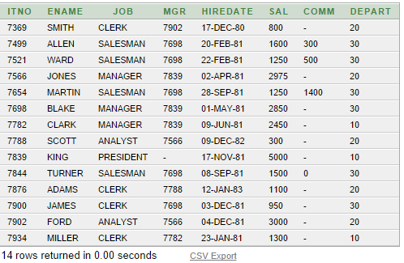

***Source code/Steps***

***DEPT TABLE***

INSERT INTO DEPT VALUE(10,'ACCOUNTING','NEW YORK');

INSERT INTO DEPT VALUES(20,'RESEARCH','DALLAS');

INSERT INTO DEPT VALUES(30,'SALES','CHICAGO');

INSERT INTO DEPT VALUES(40,'OPERATIONS','BOSTON');

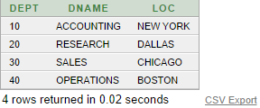

***SOURCE CODE/STEPS-:***

***INCR TABLE***

INSERT INTO INCR VALUES(7369,500,'17-DEC-83');

INSERT INTO INCR VALUES(7521,200,'20-FEB-83');

INSERT INTO INCR VALUES(7698,400,'01-MAY-83');

INSERT INTO INCR VALUES(7876,500,'12-JAN-85');

INSERT INTO INCR VALUES(7900,100,'03-DEC-83');

INSERT INTO INCR VALUES(7934,200,'23-JAN-84');

INSERT INTO INCR VALUES(7369,200,'17-DEC-85');

INSERT INTO INCR VALUES(7698,500,'20-FEB-85');

INSERT INTO INCR VALUES(7369,500,'17-DEC-87');

INSERT INTO INCR VALUES(7521,500,'20-FEB-87');

Output/Table View -:

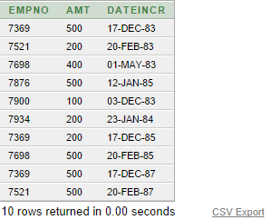

***Experiment No.2***

***A.I.M -***  *Create a table name emp,dept,incr .*

***Source Code-:***

***Emp Table -:***

create table emp

(

itno number(4),

ename varchar(20),

job char(15)

mgr number(4),

hiredate date,

sal number(9,2)

comm number(7,2),

Depart number(2)

);

***Dept Table-:***

create table dept

(

dept number(2),

dname varchar2(20),

loc varchar(10)

);

***Incr Table-:***

create table incr

(

empno number(4),

amt number(2),

dateincr date

);

***Experiment No.1***

***A.I.M-:***  Prepare a Excel File for compute a and generate a total bill of the Given order in Mc donalds.

